Test Plan
Table of Contents
Screen 2
SC01 2
SP01 2
SP02 2
SP03 3
SP04 3
SP05.1 3
SP05.2 4
Input 5
IB01 5
Time 6
DT01 6
Maze Generation 7
MG01.1 7
MG01.2 7
MGR01 7
MGR02 7
MGR03 8
MGR04.1 8
MGR04.2 8
MGR04.3 8
MGR04.3 9
MG02 9
MG03 9
MG04 10

Screen

SC01
Testing the function to make different colours in the terminal
Expected: the numbers from 0-16 in different colours and the background in a different colour.
Result is as expected with the last number not being visible due to same colour as the background, and the first white due to -1 not having a colour but done to avoid the same fate as n16 on every number.

SP01
Testing overwriting written text
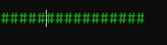
Expected: A line instead of a square of #
Result is as expected with each line overwriting the previous one.

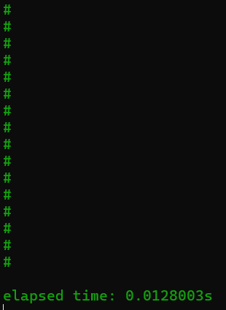
SP02
Testing overwriting written character
Expected: a line the other way from the results of SP01
Result is as expected.
Note for SP01 and SP02: Time from start to end increases a lot so may be preferential to have screen flicker and a quicker code than reduced flicker and quicker response time?

SP03
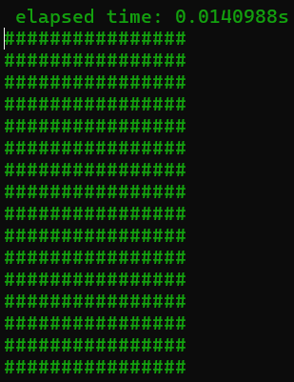
Testing moving cursor to print in a different location
Expected: That the timer is moved to the top instead.
Result is not as expected but is still a preferable result. The result shows that the cursor needs not have something printed where it moves so you can move it freely regardless of what is on screen. And with that knowledge this behaves as expected.

SP04
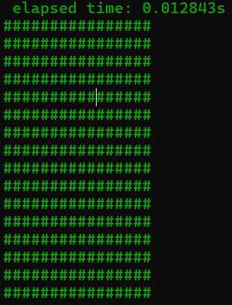
Testing if moving the cursor would overwrite previous text or insert due to behaviour from SP03
Expected: That it inserts where it is making one line in the cube extrude
Result is unexpectedly positive showing that there is no need to overwrite the lines like shown in SP01 and SP02, making the code simpler and hopefully faster.

SP05.1
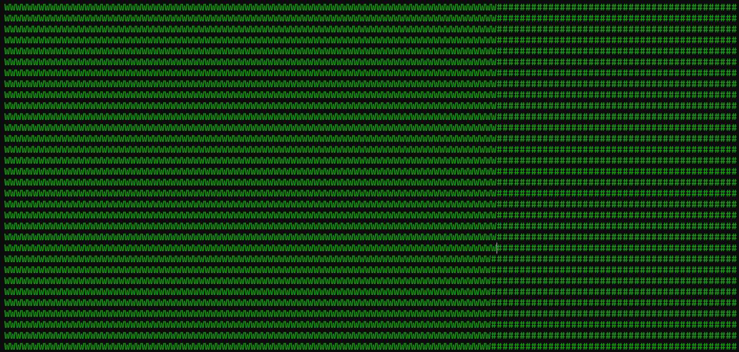
Testing only updating the screen and not constantly rewriting everything
Expected: No screen flicker and when pressing W every # on screen changes into W
Result is as expected but rather slow, possible fix is saving the changes into a string that’s printed as a whole line instead of single characters. Side note is that it is pretty to look at how it is updating.

SP05.2
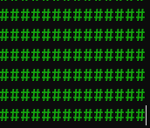
Testing Updating screen by line instead of by characters
Expected: Faster updating of the screen reducing latency/update time while keeping little to no flicker
Result: Screen updates magnitudes faster than SP05.1.
Note: cant not capture an image because of the update speed

SP06
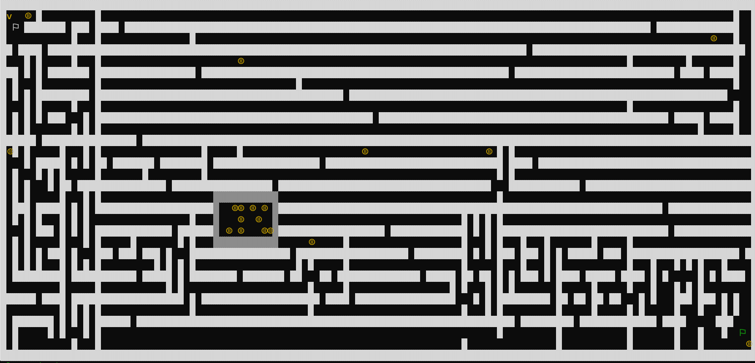
Testing printing UTF-8 characters
Expected: a flag on the start and end points as well as the coins becoming “⦷”
Result is as expected

Input

IB01
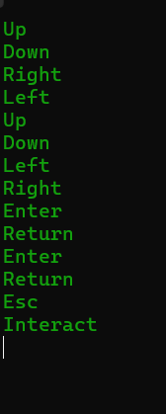
Testing base inputs from the input function
Expected: A printout from every assigned key when pressed

While the result is as expected a problem with the function that stops continuos inputs can get activated instead.

Time

DT01
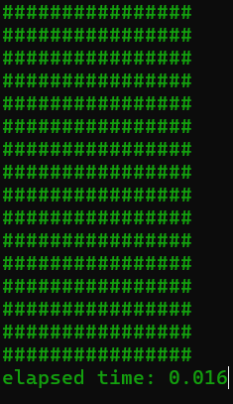
Testing how to do the delta time later
Expected: A low number showing time since the loop begun

Note: difficult to show due to screen flicker, but the result is as expected with more numbers not visible in the image

Maze Generation

MG01.1
Testing making the border
Expected: a solid border around the maze
Result is an error due to reading outside the vector’s bounds
Fix is to set the size of the vector when initialising it

MG01.2

Testing making the border
Expected: a solid border around the maze
Result is a white border as expected
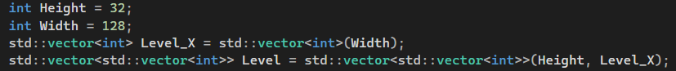
Fix from MG01.1 was surprisingly difficult with using a 2d vector since a vector can only get assigned a size in 1d so you need another vector with the second dimension to assign it


MGR01
Testing first layer of the recursive Generator
Expected: a cross placed at random inside the border with 3 holes in it
Result is as expected with the obvious problem being that the two doors on one line needs to appear on different sides of the meeting point

MGR02
Testing if the doors are put on different sides of the meeting point
Expected: one door under or besides the meeting point and one door above or on the other side of the point.

Result is as expected with the doors landing on either side every time.

MGR03
Testing making a second intersection
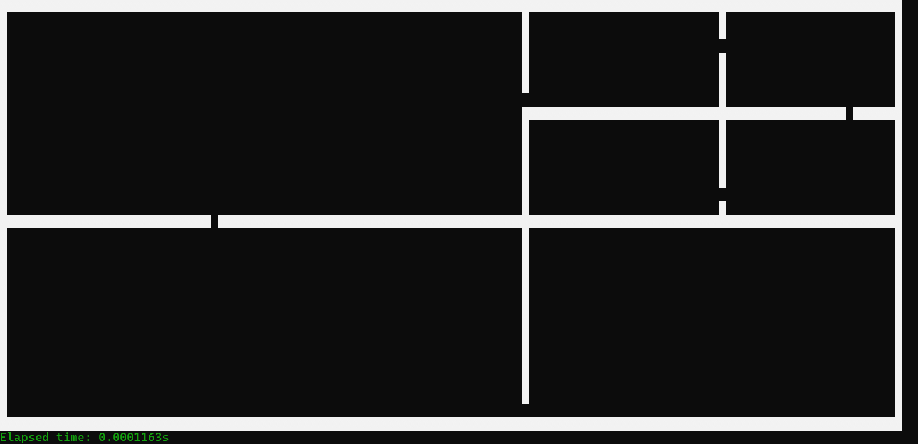
Expected: similar to the result of MGR02 with the difference of a second intersection.
Result is as expected with two intersections inside the borders.

MGR04.1
Testing the maze being generated in full
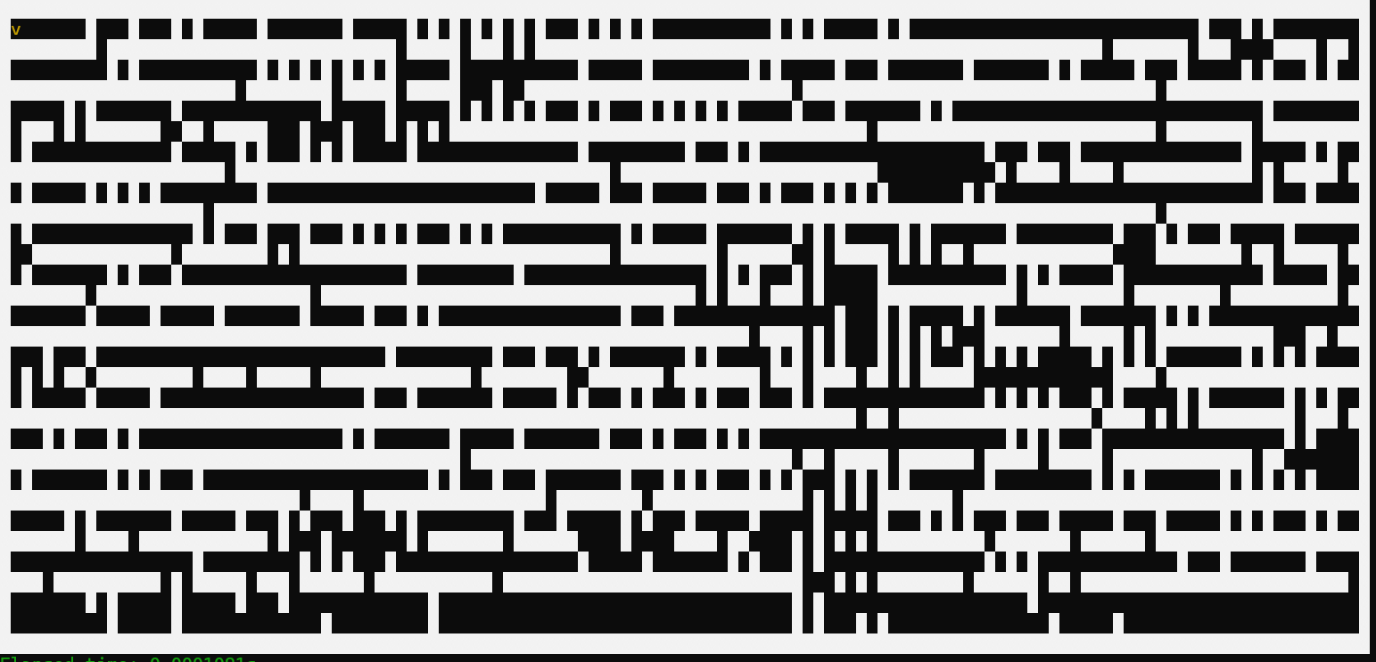
Expected: a complete maze without dead ends.
Result is not as expected due to there not being extra logic for the doors. And the fix is to set the neighbouring empty spaces to a negative value to stop the walls from generating up to it.

MGR04.2
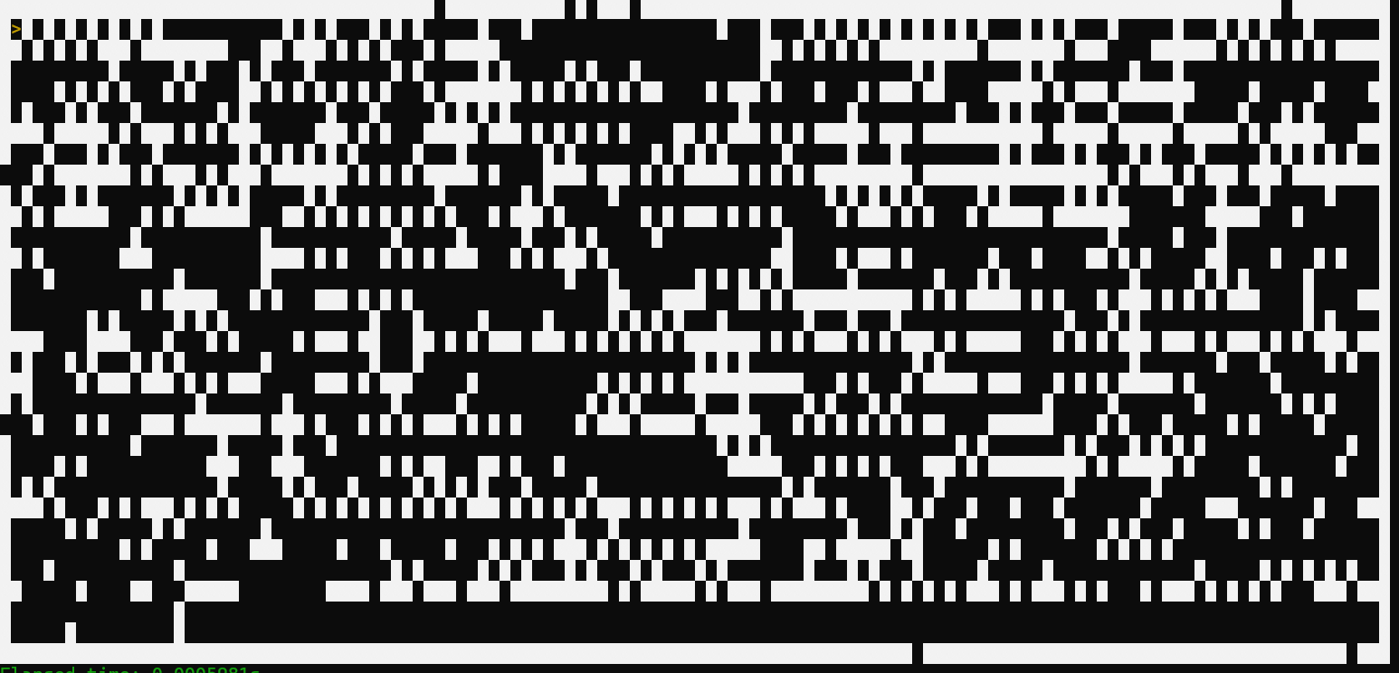
Testing the maze being generated in full
Expected: a complete maze without dead ends.
Result is completely unexpected with it looking worse than before and the maze kinda resembling a type of bar code instead.

MGR04.3
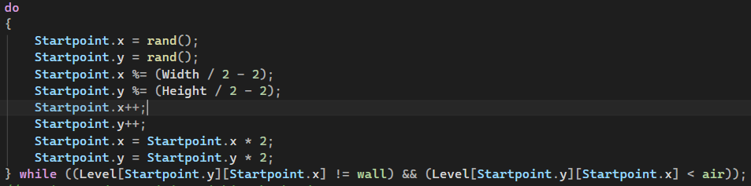
Testing the maze being generated in full
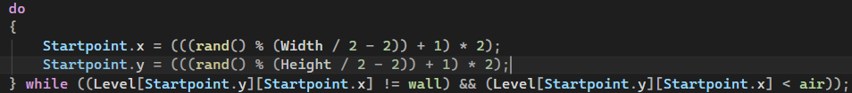
Expected: a complete maze without dead ends.
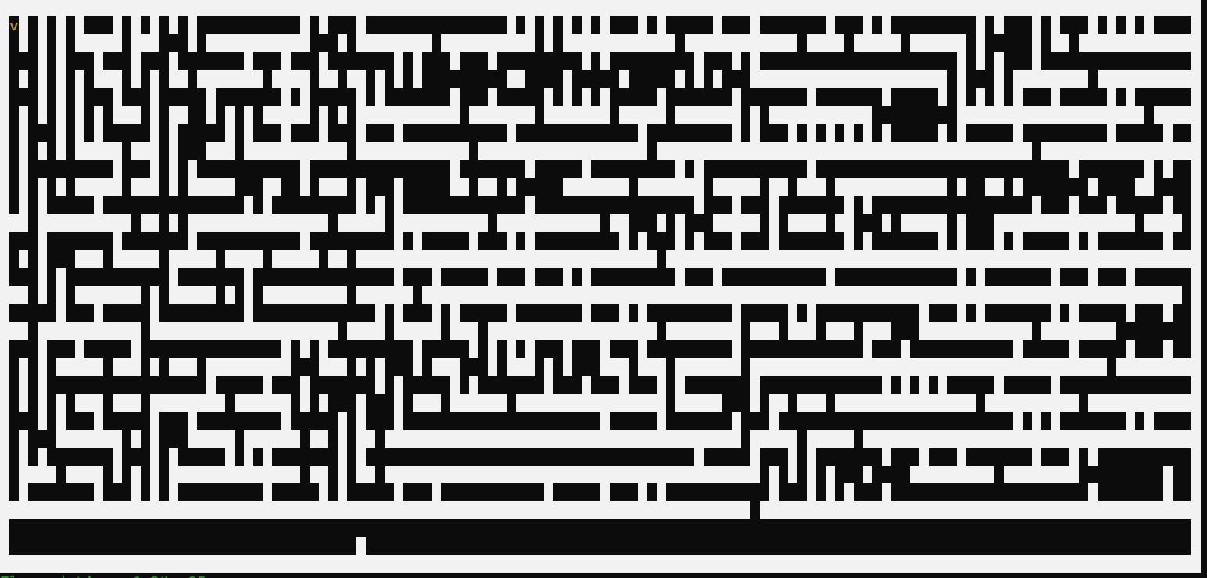
Result while compressing the code helps it does not fix the underlying problem where it seemingly ignores some walls when generating.

MGR04.3
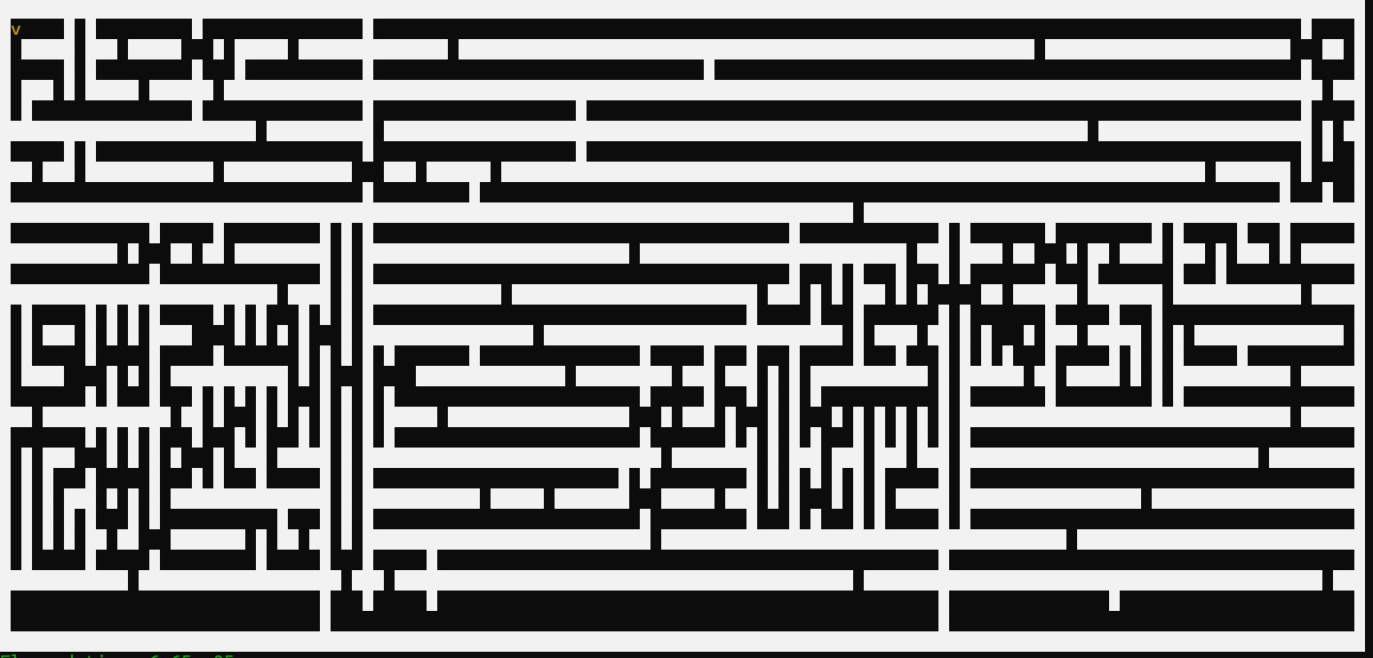
Testing the maze being generated in full
Expected: a complete maze without dead ends.
Result is as wanted with a maze without any dead ends.
Note about the algorithm is that it tends towards long straight lines and is therefore better suited to a square maze.
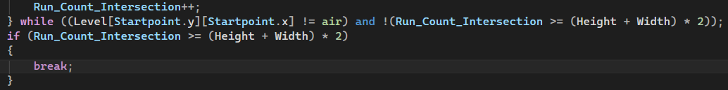
The problem with dead ends came from the fact that the air columns where excluded rather than included when checking for a valid location and makes it surprising that it worked as well as it did in the first place.

MG02
Testing making spawn and exit rooms
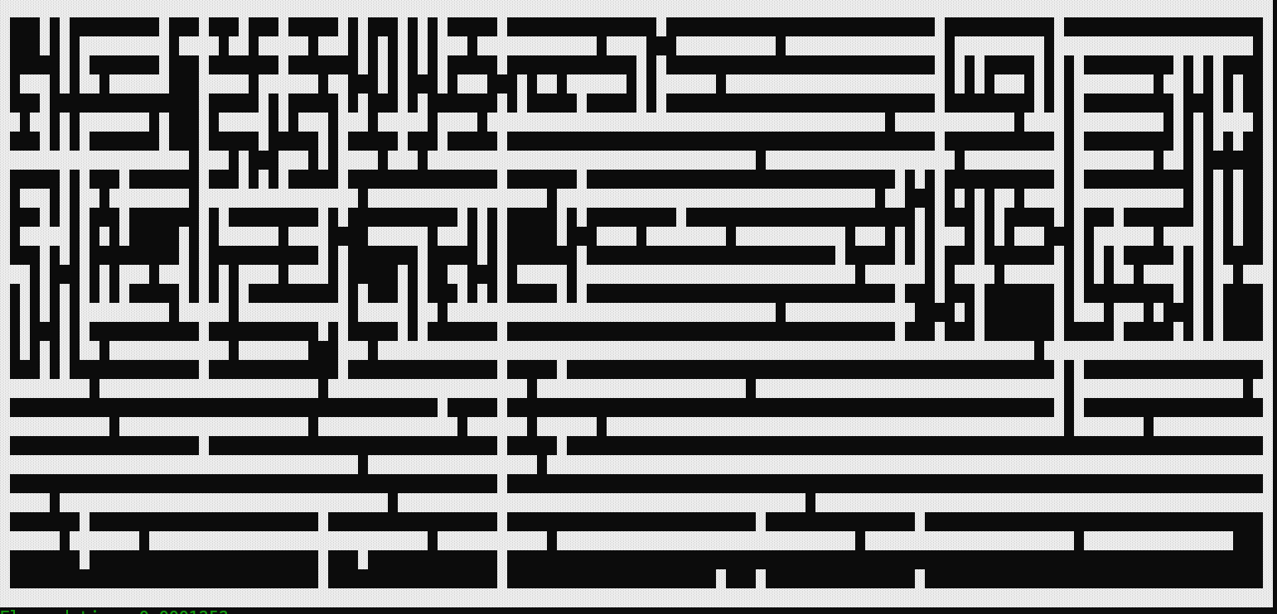
Expected: a 3x3 room on the top left and bottom right corner of the maze.
Result is as expected with an idea of changing the tiles in the future to make it more distinguishable.
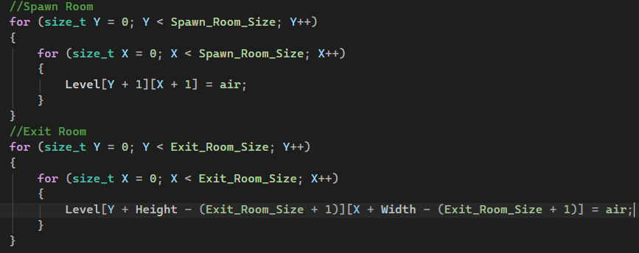
Note, the code allows to dynamically change the size in case it is wanted.

MG03
Testing spawning a loot room
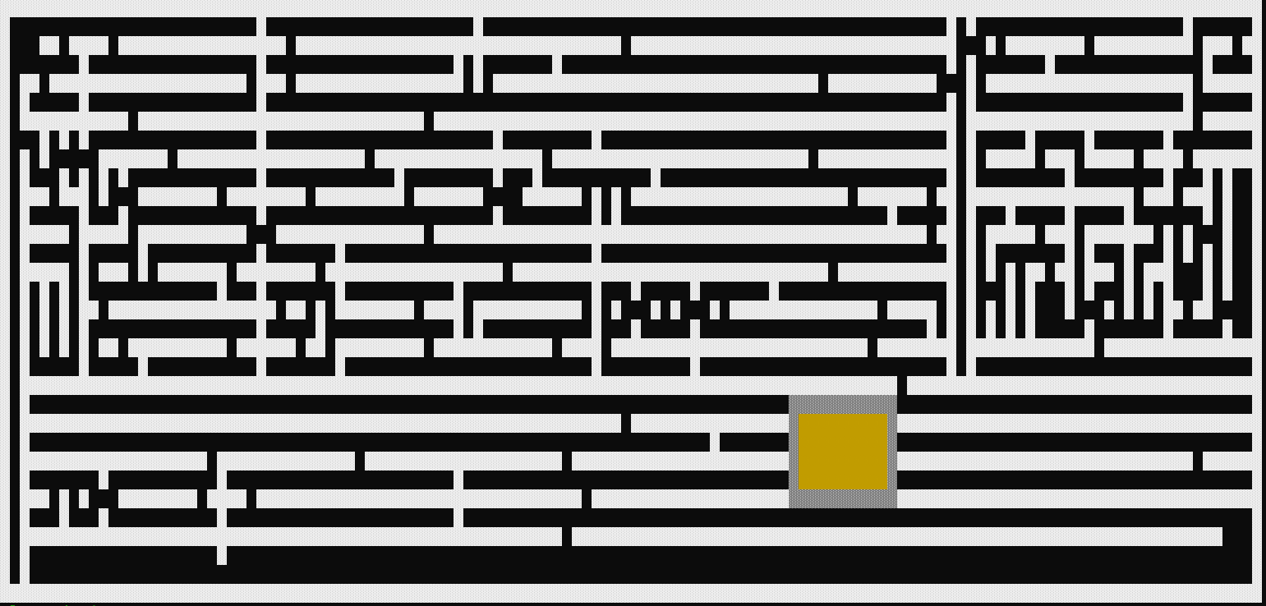
Expected: a loot room (marked in yellow) spawn randomly in the maze surrounded by breakable walls
Result: as expected. Note should spawn in straighter corridors to break up the generators maze generation.

MG04
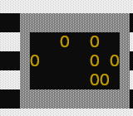
Testing spawning coins
Expected: a random amount of coins to appear in the loot room
Result is as expected with the coins appearing with a frequency of roughly 30%

MG05
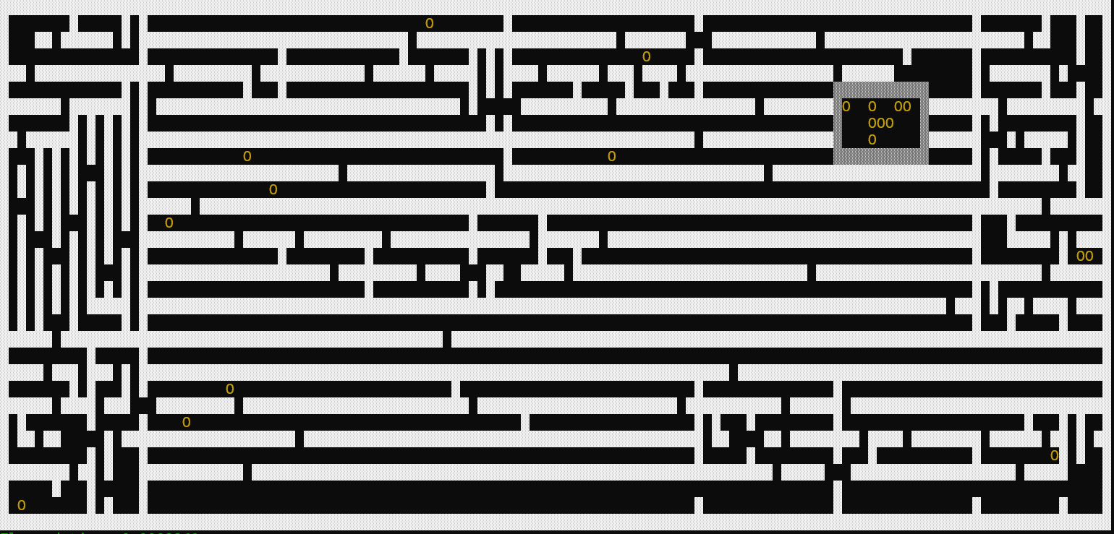
Testing spawning coins
Expected: the maze gets coins spawning randomly outside the spawning room.
Result is as expected with the coins appearing with a frequency of roughly 0.5%

